**SOO Today**

**Police swarm Leighs Bay Road; man arrested on weapons charges**

Heavy police presence at scene; traffic was blocked off in both directions

**Jan 20, 2019 5:13 PM by:**[**Darren Taylor**](https://www.sootoday.com/writers/darrentaylor)

* 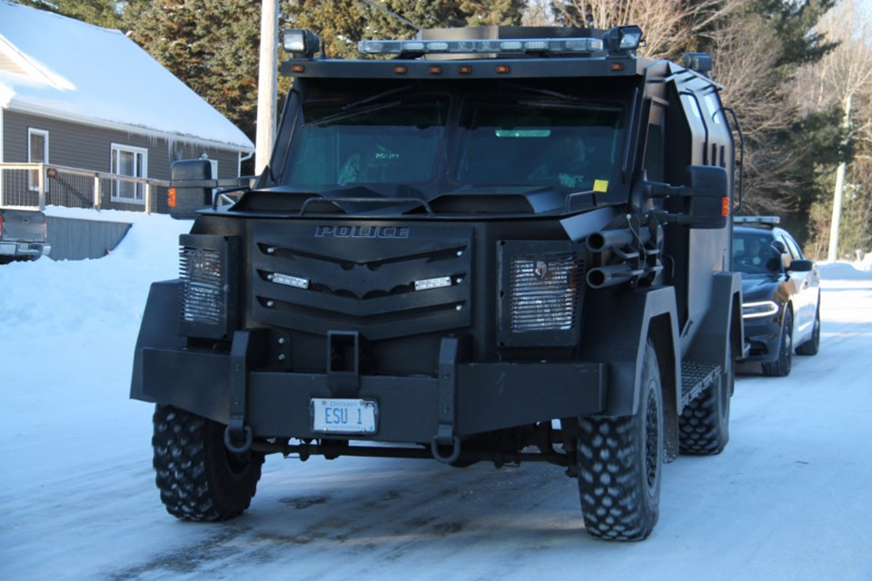

[PreviousNext](https://www.sootoday.com/local-news/police-swarm-leighs-bay-road-man-arrested-on-weapons-charges-1204510)

3 / 4 The Sault Police Ballistic Armoured Tactical Transport vehicle on Leighs Bay Road, where an incident led to one man being taken into into custody on weapons-related charges, Jan. 20, 2019. Darren Taylor/SooToday

A man is in Sault Police custody after a weapons-related incident on Leighs Bay Road Sunday afternoon.

The incident, just north of Third Line West, led to a heavy police presence, with traffic blocked off in both directions.

“We had an incident today on Leighs Bay Road. We’ve taken one male into custody on weapons-related charges. No one was injured in this incident. No fatalities, no injuries,” Insp. Mike Davey told SooToday.

A Sault Police Mobile Command Unit vehicle was set up, with several other police cars, trucks and the Ballistic Armoured Tactical Transport vehicle also on scene.

At least two Sault EMS ambulances were also present.

A neighbourhood resident, parked in his vehicle on Leighs Bay Road, told SooToday at 3 p.m. he had been waiting at the roadblock for approximately 35 minutes, with some neighbourhood families having been evacuated from their homes by police and instructed to leave the area in their vehicles for their own safety.

Police vehicles began leaving the area at 3:30 p.m.

Davey said a full statement will be released by Sault Police later.